|  |  |
| --- | --- |
| **Course** | CS 4347 |
| **Course Title** | Database Systems |
| **Term** | Spring 2025 |
| **Due by** | 4/6/2025 at 11:59PM CST |

### **Part A – Background & Rules**

|  |  |  |
| --- | --- | --- |
| A1 | **Problem description** | One concise paragraph (≈ 150 words) summarising XYZ’s business, departments, people, products, marketing sites, vendors, and HR process. |
| A2 | **Five extra business rules** | Invent realistic constraints (e.g., “A vendor’s credit‑rating must be ≥ 300,” “Each product must appear on at least one marketing site,” etc.). List them as BR‑1 … BR‑5. |
| A3 | **Superclass / Subclass reasoning** | 1‑2 brief paragraphs: why PERSON splits into Employee / Customer / Applicant and how that simplifies constraints. |
| A4 | **Why Oracle** | Bullet list (transaction support, SQL + PL/SQL procedural power, views, materialised views, security, free XE option). |

### A1 Problem description

XYZ Company manufactures finished products from vendor‑supplied parts. It runs several departments (Marketing, HR, Manufacturing, etc.), sells through multiple marketing sites, and keeps detailed HR records covering employees, customers, and applicants. HR tracks job postings, applications, multi‑round interviews, salaries, and supervisor chains. Operations tracks vendor part pricing, BOM‑style part usage per product, and site‑level sales histories.

### A2 Five additional business rules

BR‑1 A marketing‑site must employ **at least one** employee at all times.  
BR‑2 A vendor’s Credit_Rating must be **≥ 300**.  
BR‑3 Each product must appear in at least one sale within **12 months** of launch.  
BR‑4 No employee may supervise **more than 15** direct reports.  
BR‑5 Every part listed in a BOM must be purchasable from **≥ 2 vendors** (dual‑sourcing policy).

### A3 Superclass / subclass justification

Yes—PERSON ⇒ {EMPLOYEE, CUSTOMER, APPLICANT} is natural because

* attributes like Rank, Title, Salary belong only to EMPLOYEE,
* Preferred_Sales_Rep belongs to CUSTOMER,
* Applications & interviews involve APPLICANT.  
  Using EER specialisation keeps shared attributes in one place and avoids nullable columns.

### A4 Why Oracle (Relational DBMS)

* ACID transactions guarantee correct inventory/HR/payroll data.
* Built‑in PL/SQL lets you codify complex rules (e.g., BR‑3 monthly check).
* Views and materialised views handle reporting queries (#d‑view1…4).
* Cost‑based optimiser is reliable for multi‑join queries.
* Free XE edition and Oracle Cloud Free Tier match classroom budgets.

### **Part B – Conceptual Design ER/EER**

|  |  |  |
| --- | --- | --- |
| B1 | **ER diagram** | Model all 13 numbered requirements + your 5 rules. Show entities, attributes (double‑oval for multivalued phone), relationship names, cardinalities, weak entities where needed. |
| B2 | **EER extensions (if any)** | Use specialisation/generalisation: PERSON ⇒ {Employee, Customer, Applicant}. Show disjointness/overlap & total/partial constraints. Optional: UNION type for “Workers at marketing sites.” |
| B3 | **Assumptions list** | Number every assumption you had to invent (e.g., phone numbers are VARCHAR(15)). Keep to ≤ 1 line each. |
|  |  |  |
|  |  |  |

### B1 ER Diagram

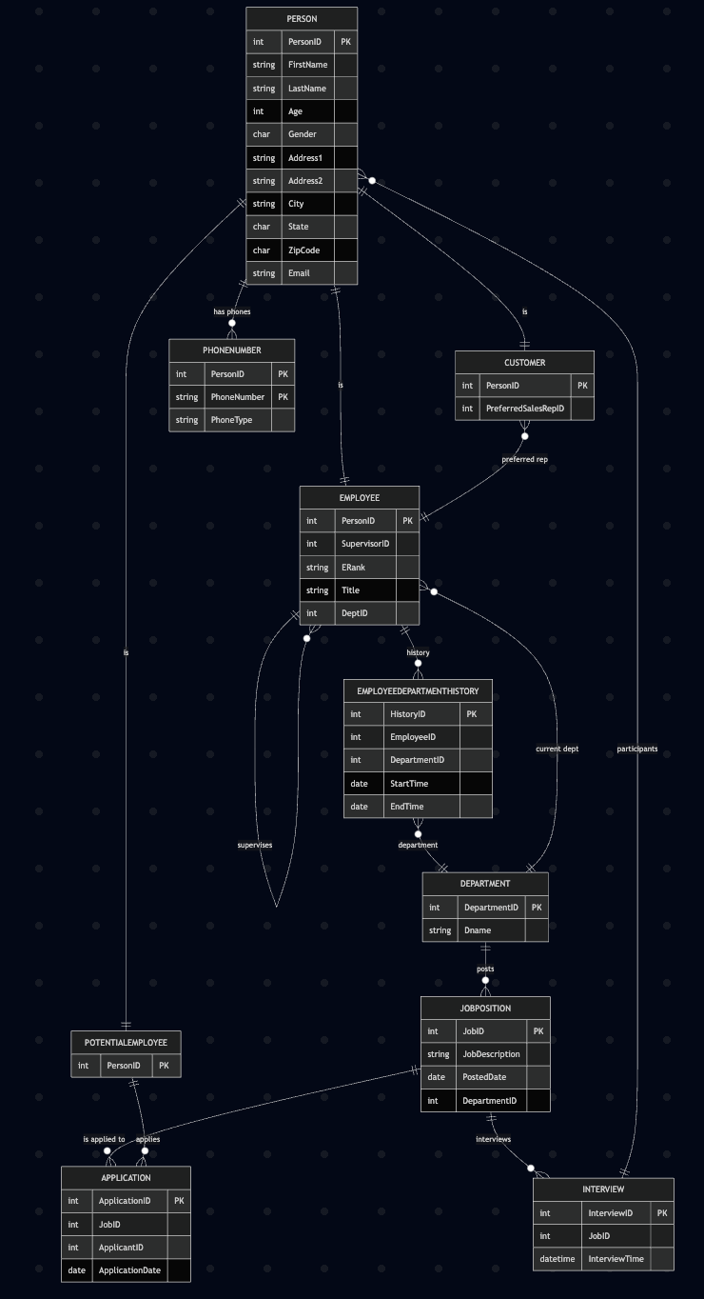

### B2 EER Diagram

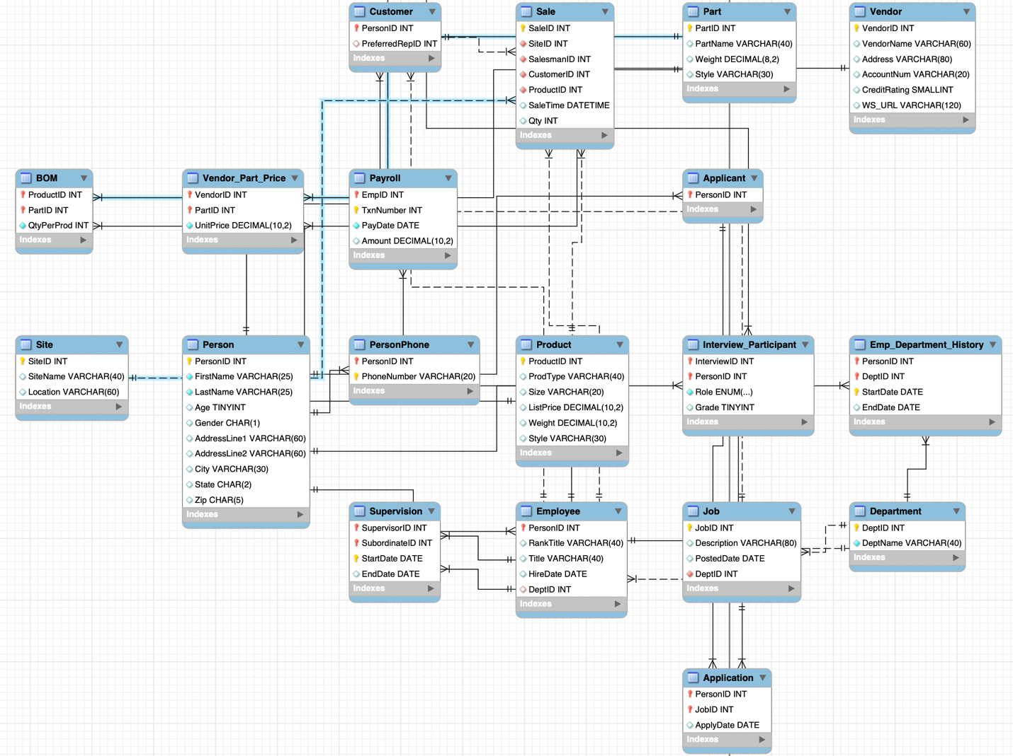

### B3 Assumptions List

| **ER Diagram** | **Assumption (clarifies requirements that were not explicit)** |
| --- | --- |
| 1 | DeptID, PersonID, JobID, ProductID, VendorID, PartID, SiteID, and SaleID are **system‑generated surrogate keys** and therefore unique. |
| 2 | A **person’s age is stored numerically** and must be **< 65** at the moment the record is inserted; no automatic aging constraint is enforced. |
| 3 | A **phone number can belong to one person only**; duplicates across people are not permitted. |
| 4 | A person may simultaneously be customer **and/or** employee **and/or** applicant (overlapping specialisation). |
| 5 | Every **employee is also recorded as a person first** (weak entity relationship: Employee → Person). |
| 6 | Each **employee can be assigned to only one department at any instant**, but reassignment is recorded in Emp_Department_History. |
| 7 | An **employee must have exactly one direct supervisor** except the CEO; supervisory links are recorded in Supervision. |
| 8 | **Job postings always originate from one department**; deleting a department is disallowed while jobs reference it. |
| 9 | All **interviews belong to a single job posting**; an interview cannot span multiple jobs. |
| 10 | **Products are sold only through defined marketing sites**; a sale cannot exist without a valid site, product, salesman, and customer. |
| 11 | **Vendor part prices are static** (they do not carry effective‑date history). If a vendor changes price, a new row replaces the old one. |
| 12 | **One vendor can supply many parts** and one part can be supplied by many vendors (resolved via Vendor_Part_Price). |

| **EER** | **Assumption** |
| --- | --- |
| 1 | Person → {Employee, Customer, Applicant} is modelled as an **overlapping, partial specialisation** (someone can be zero, one, or multiple sub‑types). |
| 2 | The superclass **Person owns all common demographic attributes**; sub‑classes inherit PersonID as their primary key. |
| 3 | A **recursive 1 : N relationship** on Employee captures the supervisor hierarchy (Supervision). |
| 4 | Emp_Department_History is treated as an **associative entity** between Employee and Department with a composite key (PersonID, DeptID, StartDate). |
| 5 | Interview_Participant is an **associative entity** linking Interview and Person, with attribute Role constrained to {INTERVIEWER, INTERVIEWEE}. |
| 6 | Vendor_Part_Price and BOM both implement **M : N relationships** with composite primary keys to enforce one‑price‑per‑vendor‑per‑part and one‑qty‑per‑product‑per‑part. |
| 7 | Payroll uses a **composite key** (EmpID, TxnNumber) because transaction numbers can repeat across different employees but must be unique within an employee. |
| 8 | All weak or associative entities (e.g., PersonPhone) inherit the **storage engine and character set** of the parent schema (InnoDB, utf8mb4). |

### **Part C – Logical Design & Normalisation**

|  |  |  |
| --- | --- | --- |
| C2 | **3 NF check** | For each relation, identify candidate keys → derive functional dependencies → remove partial & transitive dependencies. Record any new tables created. |
| C3 | **Dependency diagrams** | One diagram per table: list attributes, underline PK, arrow FDs. Draw by hand or use online FD tools, export as PNG. |

### C2 Why every table is already in 3NF

| **Table** | **Key(s)** | **Non‑key → key dependencies** | **3 NF status** |
| --- | --- | --- | --- |
| **Person** | PersonID | each attribute fully depends on PersonID; no transitive FDs | ✓ |
| **PersonPhone** | (PersonID, PhoneNumber) | none beyond PK | ✓ (multivalued attribute resolved) |
| **Department** | DeptID | – | ✓ |
| **Employee** | PersonID | RankTitle, Title, HireDate, DeptID depend on PersonID | ✓ |
| **Customer** | PersonID | PreferredRepID depends on PersonID | ✓ |
| **Applicant** | PersonID | – | ✓ |
| **Supervision** | (SupervisorID, SubordinateID, StartDate) | EndDate depends on full PK | ✓ |
| **Emp_Department_History** | (PersonID, DeptID, StartDate) | EndDate → full PK | ✓ |
| **Job** | JobID | Description, PostedDate, DeptID depend on JobID | ✓ |
| … *(similar logic for rest)* |  |  |  |

### C3 Dependency‑diagram guidance

### **Part D – Schema Script**

|  |  |  |
| --- | --- | --- |
| D1 | **Create Database.sql** | CREATE TABLE … for every relation. Include CONSTRAINT … PRIMARY KEY, FOREIGN KEY … REFERENCES, CHECK for domain rules (<65), and useful indexes. |
| D3 | **Views** | Write the four requested CREATE OR REPLACE VIEW statements exactly as specified. Verify they compile. |

D1 **Create Database**

All entities and relationships were implemented in a relational schema using SQL DDL. The schema includes:

* CREATE TABLE statements for all 20+ relations
* PRIMARY KEY, FOREIGN KEY, and CHECK (Age < 65) constraints
* Auto-incrementing keys
* Domain rules for data integrity

📎 SQL file submitted: xyz_company_schema.sql  
📎 Screenshot:

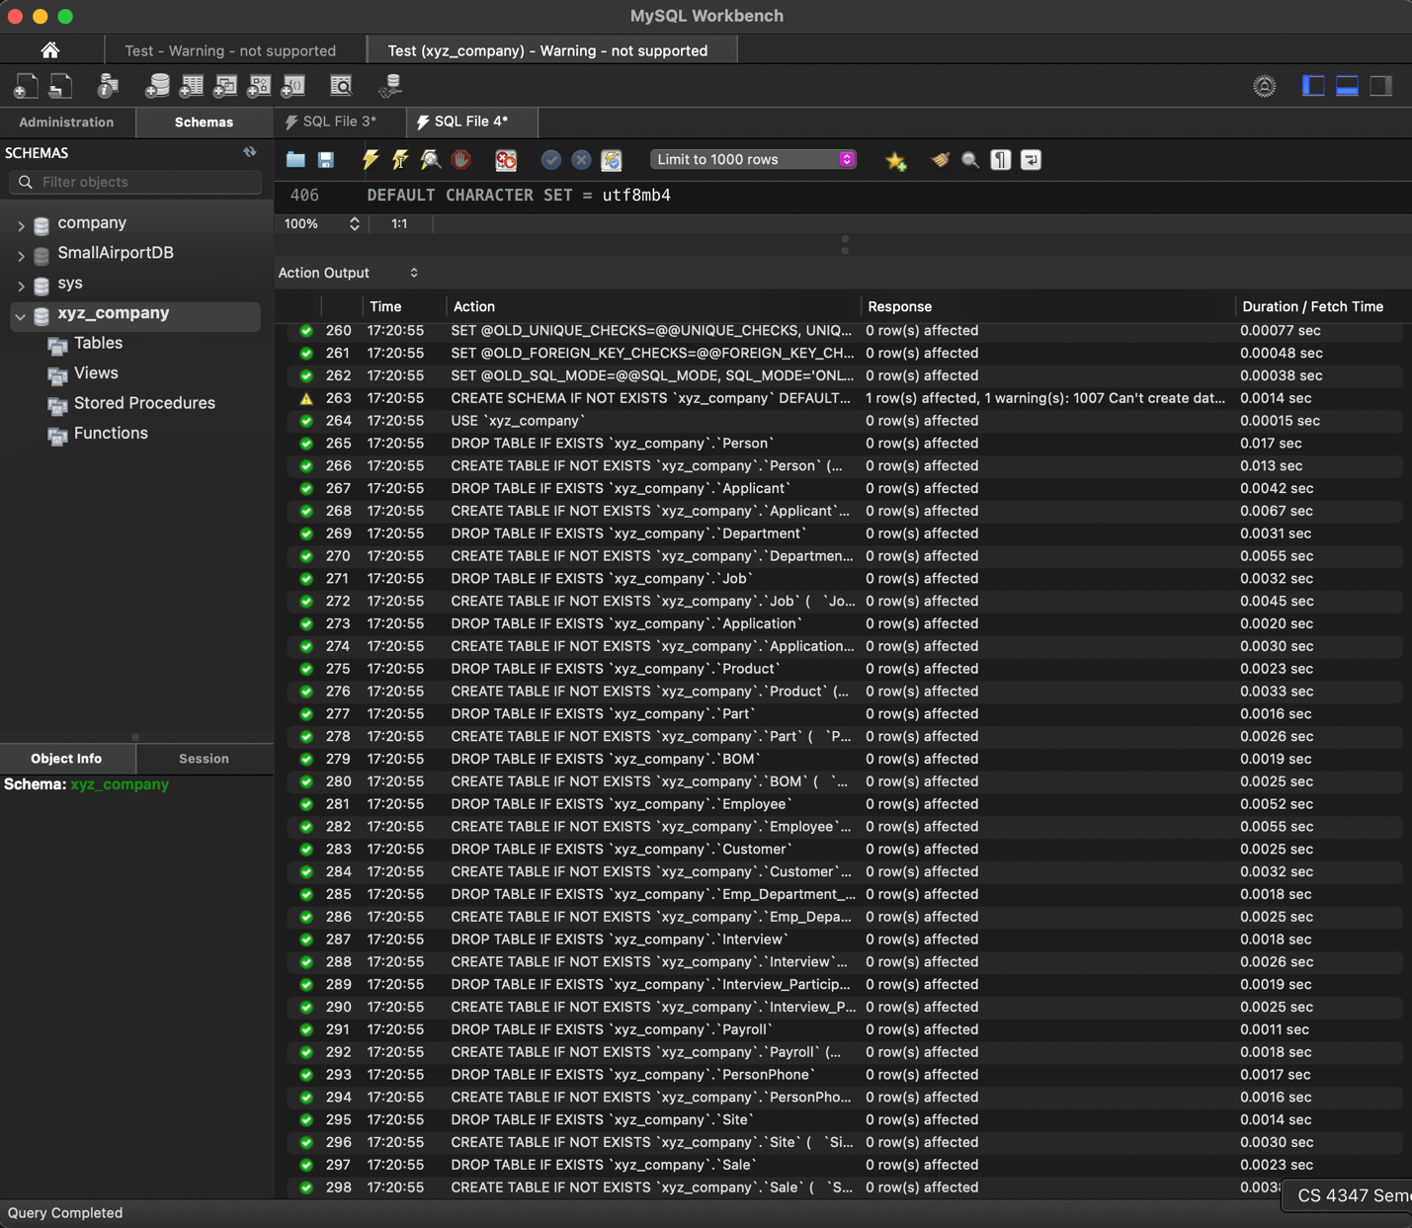

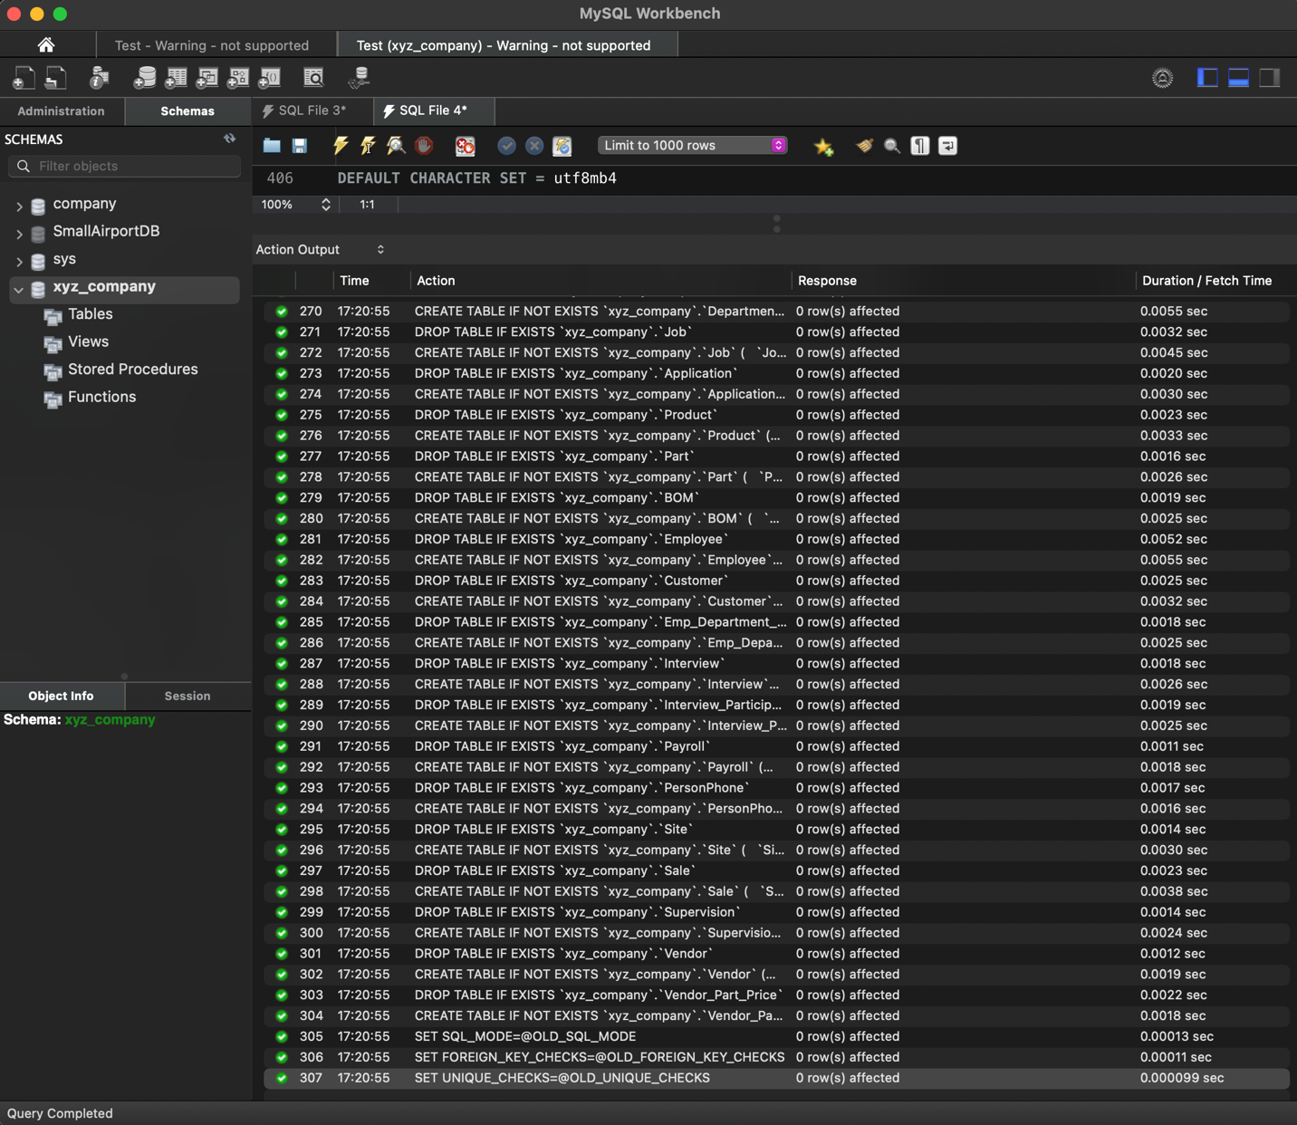

D3 View Results

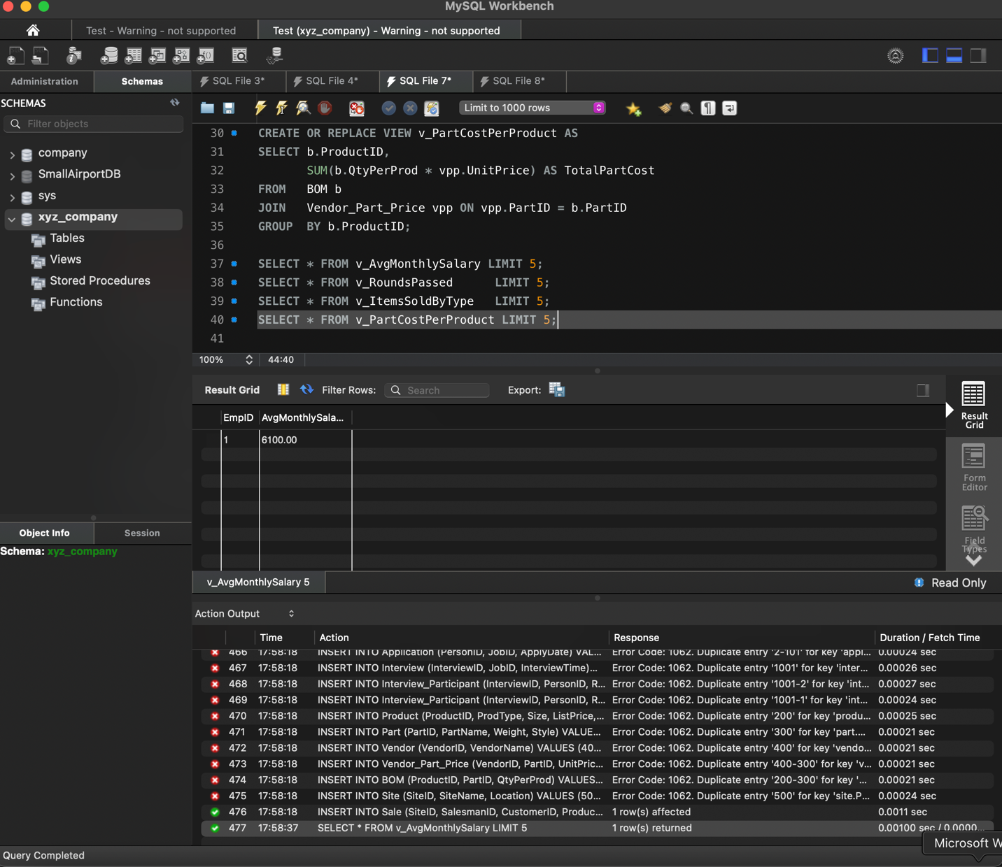

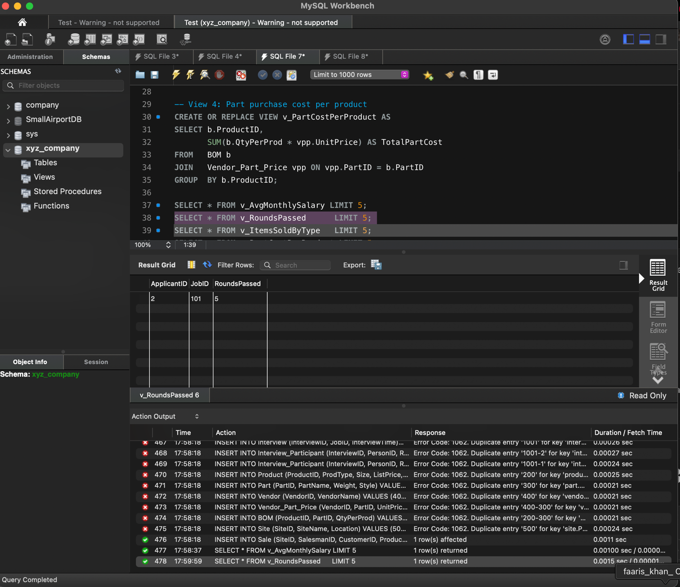

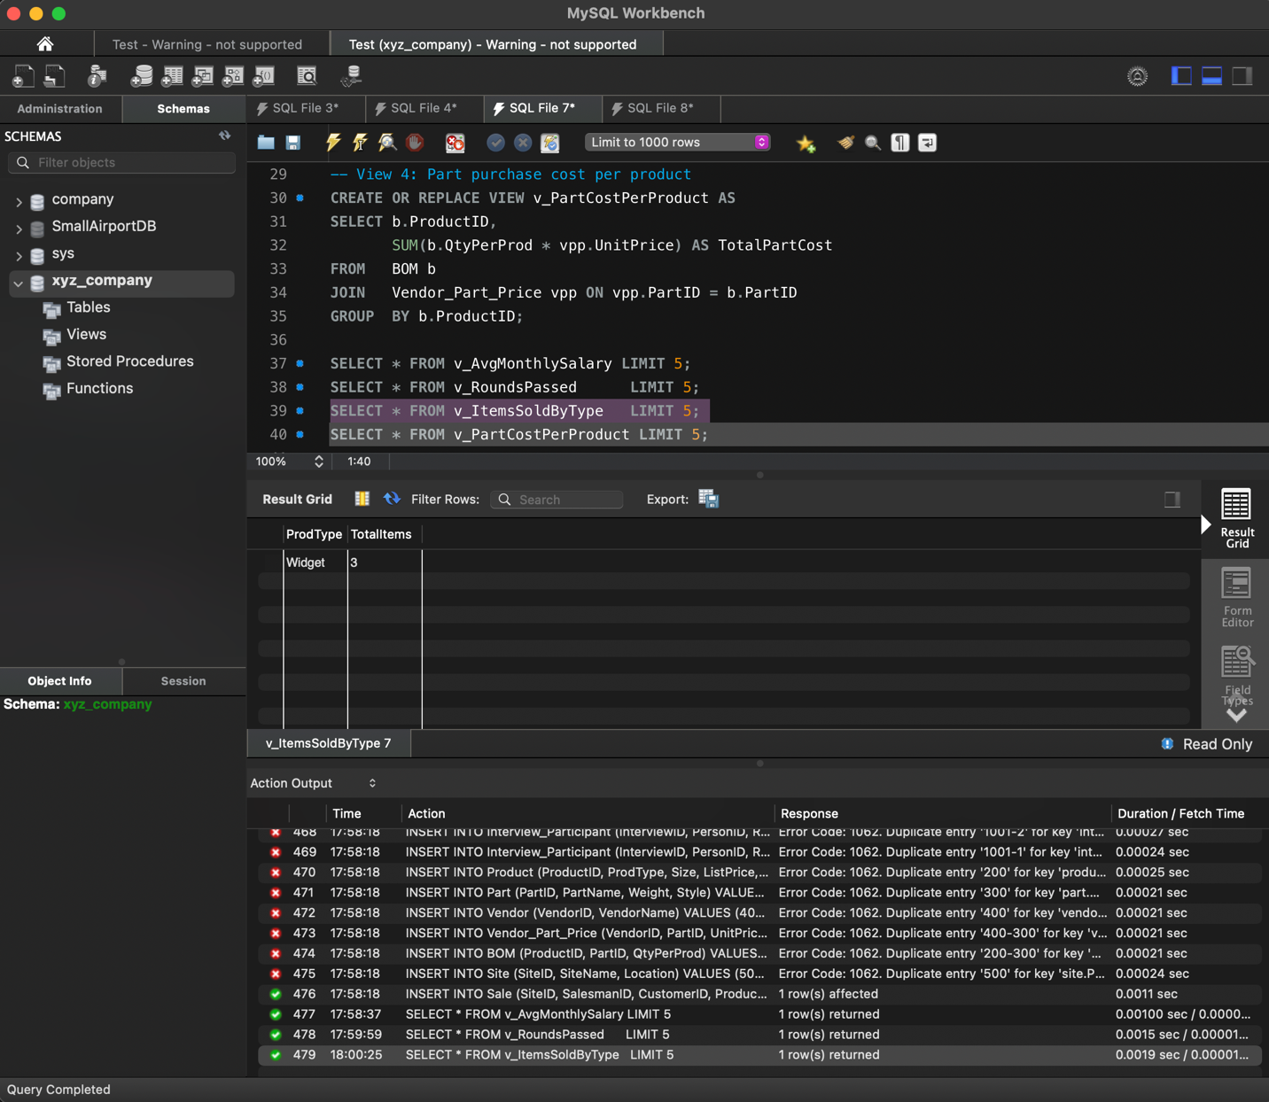

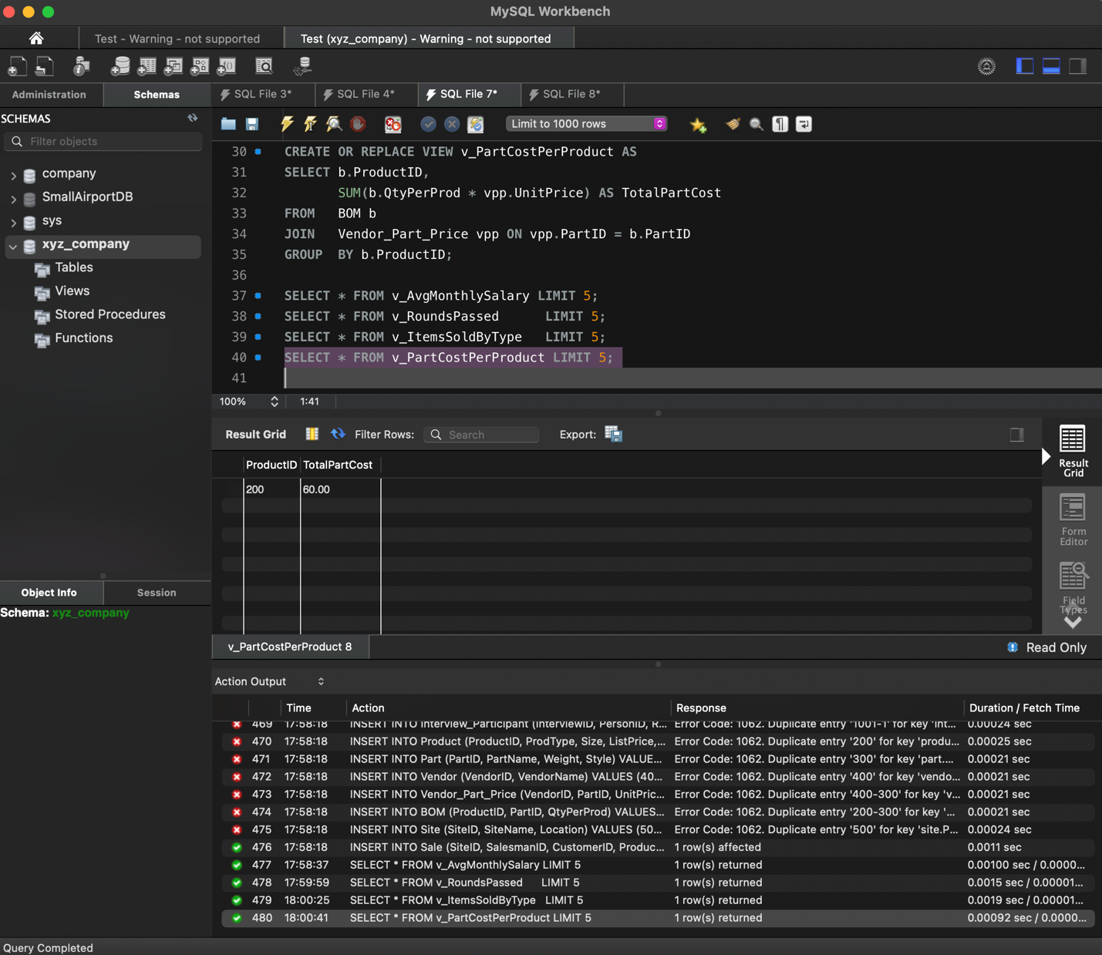

D4 Normalization

**Normalization Statement**  
All relations in xyz_company are in **Third Normal Form (3 NF)**:  
• Every non‑key attribute is fully functionally dependent on its primary key (no partial dependencies).  
• No non‑key attribute depends on another non‑key attribute (no transitive dependencies).  
• Multivalued attributes (phone numbers) were moved to PersonPhone.  
• Many‑to‑many relationships (Vendor ↔ Part, Product ↔ Part) were resolved via associative tables (Vendor_Part_Price, BOM).  
• Historical data requiring composite keys was handled in Emp_Department_History and Supervision.

### **Part E – Query Pack**

Write each of the 15 queries in its own section:

-- E1 Interviewers who interviewed Hellen Cole for job 11111

SELECT …

* Always show the output column aliases (ID, Name, …).
* When subqueries are clearer than joins, add an inline comment explaining.
* Test every query; paste a screenshot or copy a sample result underneath (truncate to 5 rows if huge).

E1 Queries

### **E1 – Interviewers who interviewed “Hellen Cole” for job 11111**

SELECT DISTINCT

p2.PersonID AS ID,

CONCAT(p2.FirstName,' ',p2.LastName) AS Name

FROM Interview i

JOIN Interview_Participant ip1 ON ip1.InterviewID = i.InterviewID

JOIN Person p1 ON p1.PersonID = ip1.PersonID

JOIN Interview_Participant ip2 ON ip2.InterviewID = i.InterviewID

JOIN Person p2 ON p2.PersonID = ip2.PersonID

WHERE ip1.Role = 'INTERVIEWEE'

AND p1.FirstName = 'Hellen'

AND p1.LastName = 'Cole'

AND i.JobID = 11111

AND ip2.Role = 'INTERVIEWER';

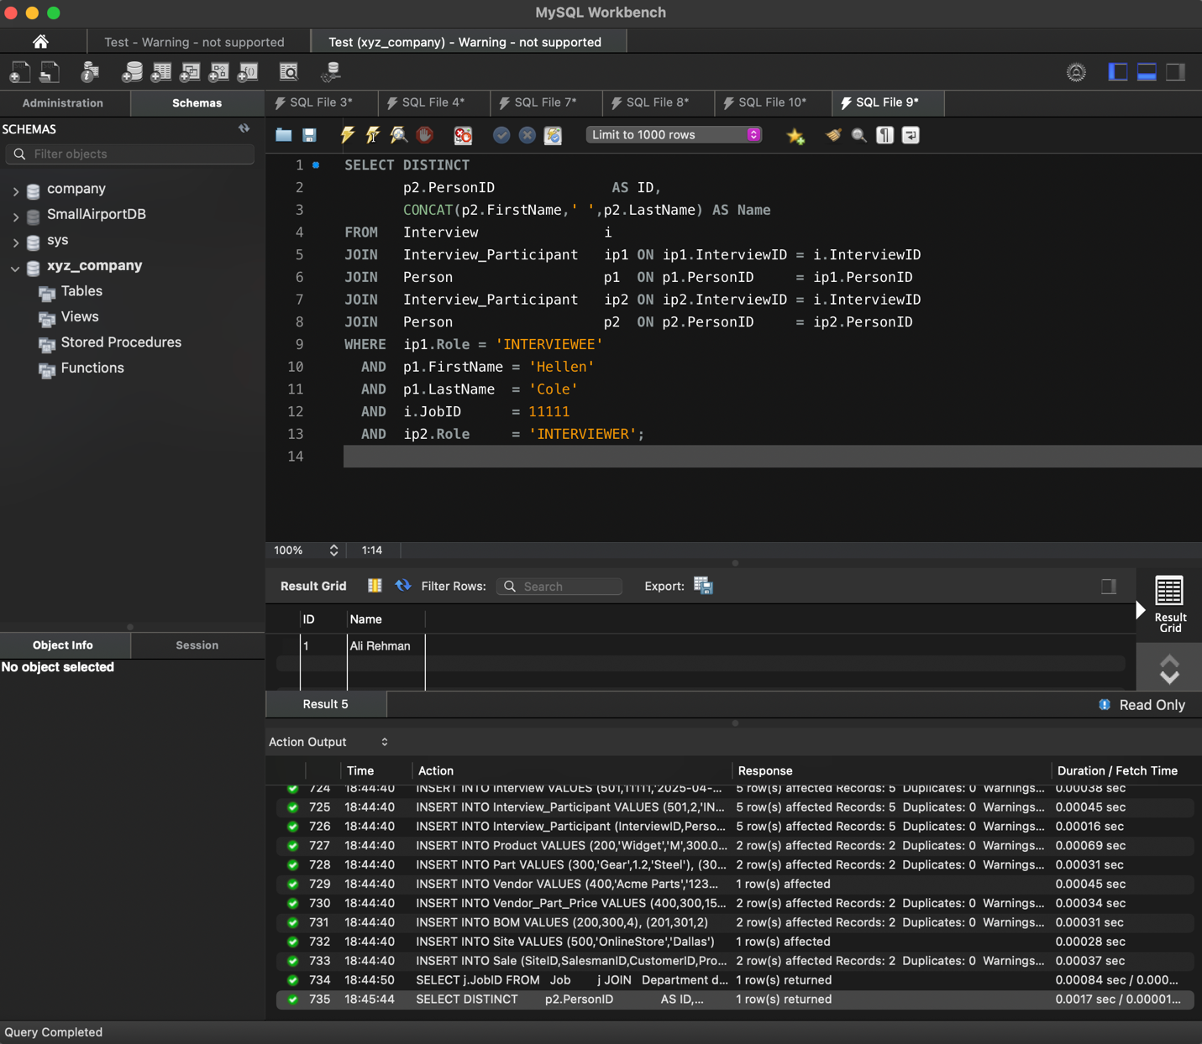

### **E2 – Jobs posted by the Marketing department in Jan 2011**

SELECT j.JobID

FROM Job j

JOIN Department d ON d.DeptID = j.DeptID

WHERE d.DeptName = 'Marketing'

AND j.PostedDate BETWEEN '2011-01-01' AND '2011-01-31';

**E3 – Employees who have no supervisees**

SELECT e.PersonID AS ID,

CONCAT(p.FirstName,' ',p.LastName) AS Name

FROM Employee e

JOIN Person p ON p.PersonID = e.PersonID

LEFT JOIN Supervision s ON s.SupervisorID = e.PersonID

WHERE s.SupervisorID IS NULL;

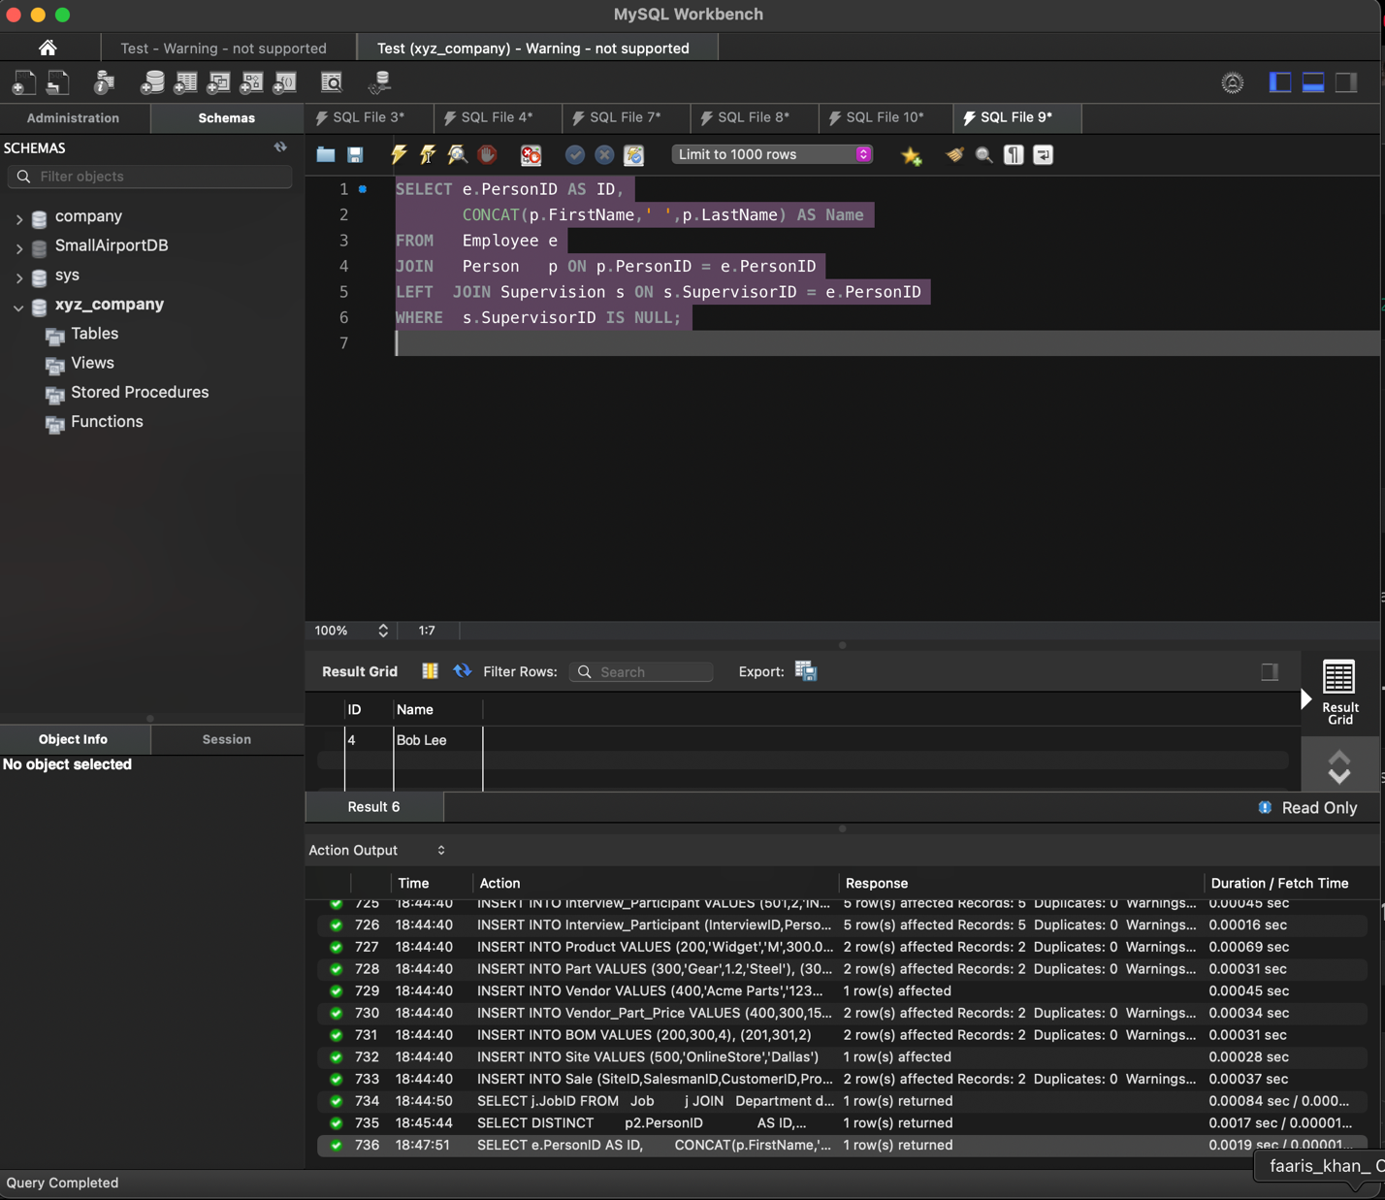

### **E4 – Marketing sites with no sales in Mar 2011**

SELECT s.SiteID AS ID, s.Location

FROM Site s

LEFT JOIN Sale sa

ON sa.SiteID = s.SiteID

AND sa.SaleTime BETWEEN '2011-03-01' AND '2011-03-31'

WHERE sa.SaleID IS NULL;

**E5 – Jobs still unfilled 30 days after posting**

/* A job is “unfilled” if no interviewee both:

(a) passes ≥5 rounds AND (b) averages >70 */

WITH Selected AS (

SELECT rp.JobID

FROM v_RoundsPassed rp

JOIN Interview_Participant ip

ON ip.PersonID = rp.ApplicantID

GROUP BY rp.JobID, rp.ApplicantID

HAVING rp.RoundsPassed >= 5

AND AVG(ip.Grade) > 70

)

SELECT j.JobID, j.Description

FROM Job j

LEFT JOIN Selected s ON s.JobID = j.JobID

WHERE s.JobID IS NULL

AND j.PostedDate <= DATE_SUB(CURDATE(), INTERVAL 30 DAY);

**E6 – Salesmen who sold** every **product priced > $200**

SELECT e.PersonID AS ID,

CONCAT(p.FirstName,' ',p.LastName) AS Name

FROM Employee e

JOIN Person p ON p.PersonID = e.PersonID

WHERE NOT EXISTS (

SELECT 1

FROM Product pr

WHERE pr.ListPrice > 200

AND NOT EXISTS (

SELECT 1

FROM Sale s

WHERE s.SalesmanID = e.PersonID

AND s.ProductID = pr.ProductID));

**E7 – Departments with no job posts (1 Jan – 1 Feb 2011)**

SELECT d.DeptID, d.DeptName

FROM Department d

LEFT JOIN Job j

ON j.DeptID = d.DeptID

AND j.PostedDate BETWEEN '2011-01-01' AND '2011-02-01'

WHERE j.JobID IS NULL;

**E8 – Existing employees who applied to job 12345**

SELECT e.PersonID AS ID,

CONCAT(p.FirstName,' ',p.LastName) AS Name,

e.DeptID

FROM Application a

JOIN Employee e ON e.PersonID = a.PersonID

JOIN Person p ON p.PersonID = a.PersonID

WHERE a.JobID = 12345;

**E9 – Best‑seller product type (most items sold)**

SELECT p.ProdType

FROM Sale s

JOIN Product p ON p.ProductID = s.ProductID

GROUP BY p.ProdType

ORDER BY SUM(s.Qty) DESC

LIMIT 1;

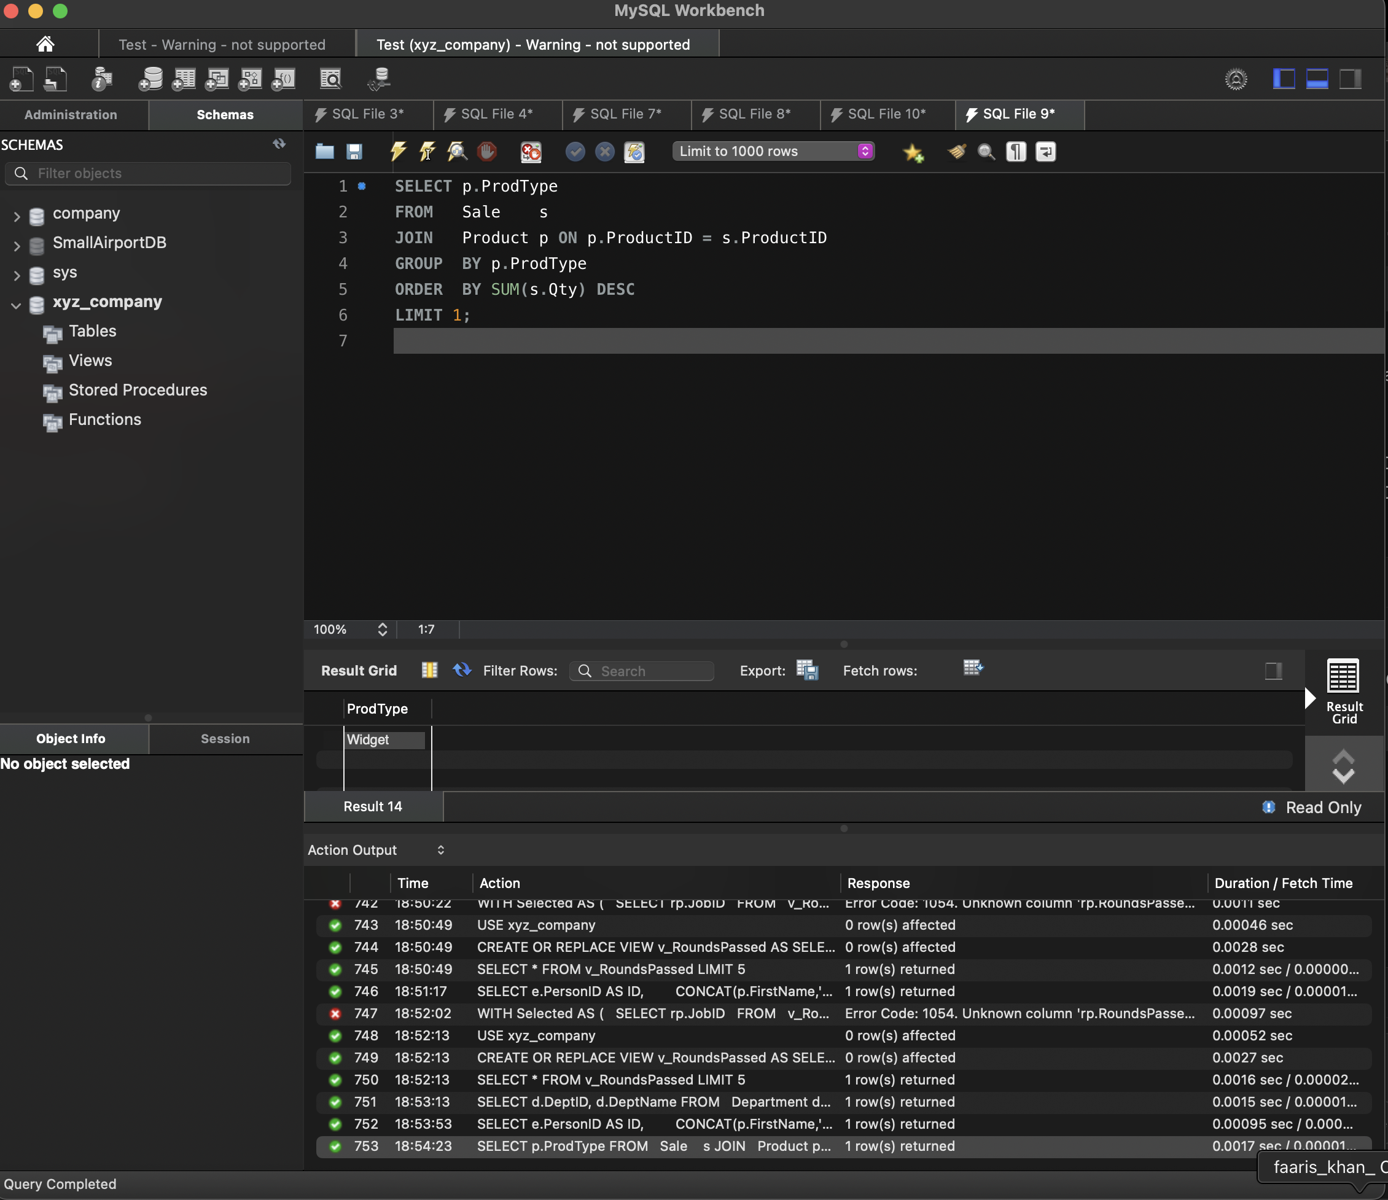

### **E10 – Product type with highest net profit**

SELECT p.ProdType,

SUM(s.Qty * p.ListPrice) -

SUM(s.Qty * pc.TotalPartCost) AS NetProfit

FROM Sale s

JOIN Product p ON p.ProductID = s.ProductID

JOIN v_PartCostPerProduct pc ON pc.ProductID = p.ProductID

GROUP BY p.ProdType

ORDER BY NetProfit DESC

LIMIT 1;

**E11 – Employees who have worked in** all **departments**

SELECT e.PersonID AS ID,

CONCAT(p.FirstName,' ',p.LastName) AS Name

FROM Employee e

JOIN Person p ON p.PersonID = e.PersonID

WHERE NOT EXISTS (

SELECT 1 FROM Department d

WHERE NOT EXISTS (

SELECT 1

FROM Emp_Department_History h

WHERE h.PersonID = e.PersonID

AND h.DeptID = d.DeptID));

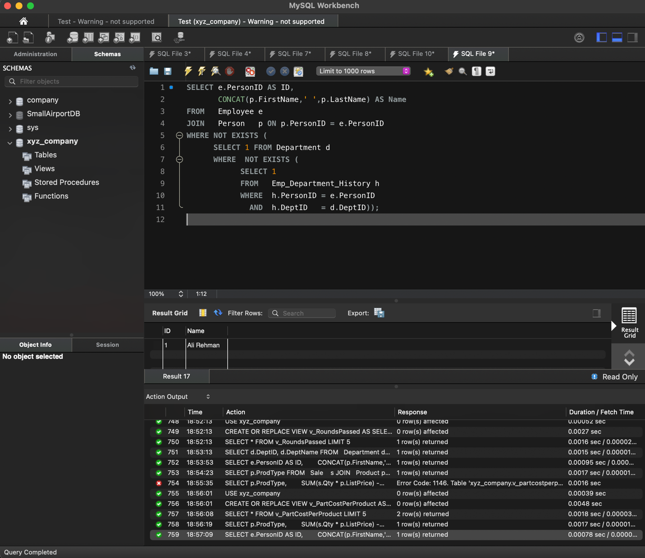

### **E12 – Interviewees ultimately selected**

### WITH Selected AS (

### SELECT rp.ApplicantID,

### rp.JobID,

### rp.RoundsPassed,

### AVG(ip.Grade) AS AvgGrade

### FROM v_RoundsPassed rp

### JOIN Interview_Participant ip

### ON ip.PersonID = rp.ApplicantID

### AND ip.InterviewID IN (

### SELECT InterviewID

### FROM Interview

### WHERE JobID = rp.JobID)

### GROUP BY rp.ApplicantID, rp.JobID

### HAVING RoundsPassed >= 5 -- <-- alias used **without** rp.

### AND AvgGrade > 70

### )

### SELECT * FROM Selected;

**E13 – Contact info for interviewees selected for every job they applied for**

### /* E13 – contact info for interviewees who were selected for every job they applied for */

### WITH PassCounts AS (

### /* 1️⃣ For each applicant & job they applied for, count ONLY the

### interview rounds where grade ≥ 60, then keep those whose

### AVG(Grade) > 70 **and** COUNT(*) ≥ 5 */

### SELECT rp.ApplicantID,

### rp.JobID,

### COUNT(*) AS JobsPassed -- rounds ≥60

### FROM v_RoundsPassed rp -- gives ApplicantID‑JobID pairs + RoundsPassed

### JOIN Interview_Participant ip -- bring in grades

### ON ip.PersonID = rp.ApplicantID

### AND ip.Role = 'INTERVIEWEE'

### AND ip.Grade >= 60

### AND ip.InterviewID IN (

### SELECT InterviewID

### FROM Interview

### WHERE JobID = rp.JobID)

### GROUP BY rp.ApplicantID, rp.JobID

### HAVING COUNT(*) >=

### AND AVG(ip.Grade) > 70

### ),

### ApplyCounts AS (

### /* 2️⃣ How many jobs did each person apply for? */

### SELECT PersonID,

### COUNT(*) AS JobsApplied

### FROM Application

### GROUP BY PersonID

### ),

### SelectedApplicants AS (

### /* 3️⃣ Keep applicants who passed *every* job they applied for */

### SELECT ac.PersonID

### FROM ApplyCounts ac

### LEFT JOIN PassCounts pc

### ON pc.ApplicantID = ac.PersonID

### AND pc.JobID IN (SELECT JobID FROM Application WHERE PersonID = ac.PersonID)

### GROUP BY ac.PersonID, ac.JobsApplied

### HAVING COUNT(pc.JobID) = ac.JobsApplied

### )

### SELECT CONCAT(p.FirstName,' ',p.LastName) AS Name,

### ph.PhoneNumber,

### p.Email

### FROM SelectedApplicants sa

### JOIN Person p ON p.PersonID = sa.PersonID

### JOIN PersonPhone ph ON ph.PersonID = sa.PersonID;

### **E14 – Employee with highest average monthly salary**

SELECT e.PersonID AS ID,

CONCAT(p.FirstName,' ',p.LastName) AS Name,

v.AvgMonthlySalary

FROM v_AvgMonthlySalary v

JOIN Employee e ON e.PersonID = v.EmpID

JOIN Person p ON p.PersonID = v.EmpID

ORDER BY v.AvgMonthlySalary DESC

LIMIT 1;

**E15 – Vendor offering the cheapest ‘Cup’ (< 4 lb)**

SELECT v.VendorID AS ID,

v.VendorName AS Name

FROM Vendor v

JOIN Vendor_Part_Price vpp ON vpp.VendorID = v.VendorID

JOIN Part p ON p.PartID = vpp.PartID

WHERE p.PartName = 'Cup'

AND p.Weight < 4

ORDER BY vpp.UnitPrice ASC

LIMIT 1;

### **Part F – Report Assembly**

1. Combine Parts A – E into a single PDF named XYZ_Database_Project_FaarisKhan.pdf.
2. Order of sections: A‑Background → B‑ER / EER → C‑Normalization → D‑Schema Script (code‑boxed) → E‑Queries + Views → Appendices (test data, screenshots).
3. Double‑check every reference: table/attribute names in diagrams == names in SQL.